**19. Kubernetes Services – Introduction**

--- **note** – we have multiple services available here.

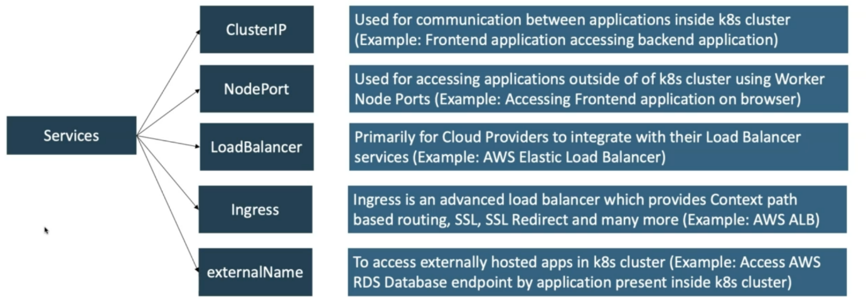

**Services explanation**

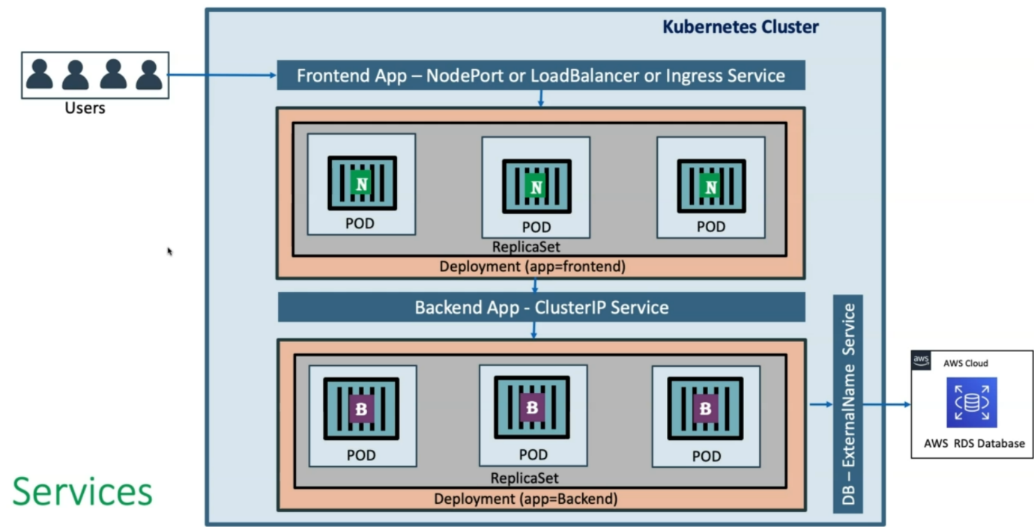

--- let’s consider in a kubernetes cluster, you have deployed your backend application. This backend application is currently using an amazon RDS database which is in aws. If you want to access that from inside of your kubernetes cluster you need to define **DB – ExternalName service**

--- in the same way you have your frontend application and this frontend application needs to access the backend application, for this purpose you need to define a cluster ip service in your kubernetes cluster.

--- your users want to access your application which is hosted on kubernetes cluster. For that purpose, you will deploy your NodePort or LoadBalancer or ingress service.